Name: Gunjit Sinha, Harsh Narain, Anamika Singh, Santanu Jana
Batch: DS ProX55
Title: Dynamic Risk Profiling and Performance Analysis in Consumer Lending
Dataset: loan_final313_.csv

Dynamic Risk Profiling & Performance Analysis in Consumer Lending

Overview
The consumer lending landscape has undergone significant transformation in recent years, driven by evolving economic conditions, technological advancements, and changing consumer behaviors. In this dynamic environment, lenders face the challenge of managing a diverse loan portfolio while balancing profitability with risk. The ability to effectively analyze and interpret loan data is crucial for making informed decisions and maintaining a competitive edge.
The loan dataset in this case study offers a rich source of information, encompassing various aspects of the lending process, including borrower demographics, loan characteristics, financial metrics, and repayment histories. It provides an opportunity to delve deep into the patterns and trends that govern consumer lending, offering insights into risk management, borrower behavior, and financial performance.

Objective
The objective of this case study is to apply advanced data analysis techniques using Excel to deeply understand and effectively manage a loan portfolio. This involves assessing loan risk profiles, evaluating financial performance metrics, gaining insights into borrower behaviors, and ultimately, developing a comprehensive, interactive Excel dashboard. These efforts aim to provide strategic recommendations for optimizing loan portfolio management, mitigating risks, and enhancing decision-making processes for financial institutions and stakeholders in the consumer lending sector.

ETL Phase
All the extraction, transformation, and loading tasks are performed in the following Google Collab notebook:
ETL.ipynb

The notebook integrates with SQL using sqlite3.
All the results are displayed using pandas.

Extraction

Question.
Create a table named loans with appropriate data types for all columns listed in the dataset (loan_final313_.csv).

Answer.
CREATE TABLE loans (
id INTEGER PRIMARY KEY,
year INTEGER,
issue_d TEXT,
final_d TEXT,
emp_length_int INTEGER,
home_ownership TEXT,
home_ownership_cat INTEGER,
income_category TEXT,
annual_inc REAL,
income_cat INTEGER,
loan_amount REAL,
term INTEGER,
term_cat INTEGER,
application_type TEXT,
application_type_cat INTEGER,
purpose TEXT,
purpose_cat INTEGER,
interest_payments TEXT,
interest_payment_cat INTEGER,
loan_condition TEXT,
loan_condition_cat INTEGER,
interest_rate REAL,
grade TEXT,
grade_cat INTEGER,
dti REAL,
total_pymnt REAL,
total_rec_prncp REAL,
recoveries REAL,
installment REAL,
region TEXT
);

Question.
Import the loan_final313_.csv file into your SQL environment (e.g., MySQL, PostgreSQL, SQL Server).

Answer.
conn = sqlite3.connect("data.db")
df.to_sql("loans", conn, if_exists="replace", index=False)
print("Loaded", df.shape[0], "rows into loans table.")

Question.
Display the first 10 records from the table to confirm successful loading.

Answer.
select *
from loans
limit 10;

Question.
Check the total number of records and distinct loan years.

Answer.
select count(*) as total_records
from loans;
select distinct year
from loans;

Question.
List all unique values for key categorical variables like home_ownership, loan_condition, and purpose.

Answer.
select distinct home_ownership
from loans;
select distinct loan_condition
from loans;
select distinct purpose
from loans;

Transformation
Question.
Identify missing or null values in critical columns (loan_amount, interest_rate, annual_inc, loan_condition, purpose).

Answer.
select
sum(case when loan_amount is null or loan_amount = '' then 1 else 0 end) as missing_loan_amount,
sum(case when interest_rate is null or interest_rate = '' then 1 else 0 end) as missing_interest_rate,
sum(case when annual_inc is null or annual_inc = '' then 1 else 0 end) as missing_annual_inc,
sum(case when loan_condition is null or loan_condition = '' then 1 else 0 end) as missing_loan_condition,
sum(case when purpose is null or purpose = '' then 1 else 0 end) as missing_purpose
from loans;

Question.
Replace missing income values with the median income of all borrowers.

Answer.
with ordered as (
select
cast(annual_inc as real) as annual_inc,
row_number() over (order by cast(annual_inc as real)) as rn,
count(*) over () as cnt
from loans
where annual_inc is not null and trim(annual_inc) <> ''
), -- adds rank & total_count for each row
median_value as (
select avg(annual_inc) as median_ann_inc
from ordered
where rn in ( (cnt + 1) / 2, (cnt + 2) / 2 )
) -- uses rank & total_count to find the two middle values to calculate median
update loans
set annual_inc = (select median_ann_inc from median_value)
where annual_inc is null or trim(annual_inc) = ''

Question.
Standardize categorical values — for example, convert all home_ownership entries to uppercase for consistency.

Answer.
update loans
set home_ownership = upper(home_ownership),
application_type = upper(application_type),
purpose = upper(purpose),
loan_condition = upper(loan_condition),
region = upper(region);

Question.
Create a new column profitability that measures the difference between total_pymnt and loan_amount.

Answer.
alter table loans
add profitability real;
update loans
set profitability = total_pymnt - loan_amount;

Question.
Create a new column risk_flag based on the loan condition:
If loan_condition = ‘Bad Loan’ → risk_flag = 1, else → risk_flag = 0

Answer:
alter table loans
add column risk_flag integer;
update loans
set risk_flag =
case
when loan_condition = 'BAD LOAN' then 1
else 0
end;

Loading
Question.
Add a default_rate_indicator column that computes the ratio of defaulted loans (Bad Loan) to total loans within the same year.

Answer.
alter table loans
add column default_rate real;
with year_rate as (
select year,
1.0 * sum(case when loan_condition = 'BAD LOAN' then 1 else 0 end) / count(*) as rate
from loans
group by year
)
update loans
set default_rate = (
select rate
from year_rate yr
where yr.year = loans.year
);

Question.
Extract loan term as numeric value (e.g., convert ‘36 months’ → 36).

Answer.
update loans
set term = cast(
replace(lower(trim(term)), ' months', '') as integer
);

Question.
Add a new column income_to_loan_ratio calculated as the borrower’s annual income divided by the loan amount.

Answer.
alter table loans
add column income_to_loan_ratio real;
update loans
set income_to_loan_ratio = 1.0*annual_inc/loan_amount;

Question.
Export the cleaned and enriched dataset (loans_cleaned) from SQL to a .csv file for use in Excel

Answer.
df = pd.read_sql_query("select * from loans", conn)
df.to_csv("/content/drive/MyDrive/AB DA Track - ETL/loans_cleaned.csv")
conn.close()
print("dataset extracted")

Excel Data Analysis

The accompanying Excel workbook comprehensively documents the analytical procedures applied to the loan dataset. This includes data cleaning, generation of summary statistics, pivot table analysis, trend charting, correlation visualization, and categorical segmentation. Each specific task or question is addressed on a dedicated sheet to facilitate straightforward navigation and review of the findings. Furthermore, a fully functional Dashboard has been developed for advanced analysis.
The comprehensive, interactive visualization tool developed for strategic insights and decision-making is located here:
- Loan Portfolio Risk Analysis Dashboard.xlsx
Dashboard
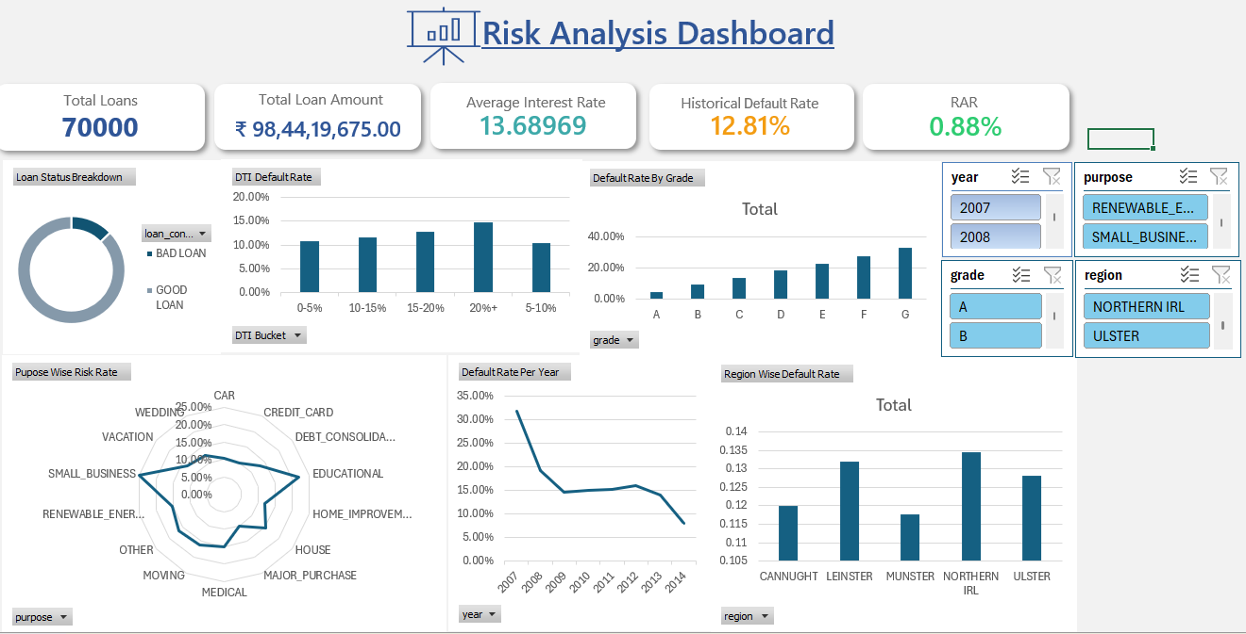

📝 Project Summary Analysis: Dynamic Risk Profiling and Performance in Consumer Lending
This project successfully executed a comprehensive data analysis pipeline, moving from raw data to actionable business insights, specifically focused on Dynamic Risk Profiling and Performance Analysis in Consumer Lending.

ETL Phase Summary
The Extraction, Transformation, and Loading (ETL) phase was completed using a Google Colab notebook (ETL.ipynb) which integrated with SQL (sqlite3) for data manipulation.
- Extraction: Data was successfully loaded from the loan_final313_.csv dataset into a SQL table named loans.
- Transformation: Key data cleaning and feature engineering tasks were performed:
  - Missing income values were replaced using the median income.
  - Categorical variables like home_ownership and loan_condition were standardized to uppercase for consistency.
  - New, critical financial metrics were calculated, including profitability (total_pymnt - loan_amount) and the risk_flag (1 for 'Bad Loan', 0 otherwise).
- Loading: The final structure included newly engineered columns designed for risk assessment, such as default_rate (ratio of defaulted loans per year) and income_to_loan_ratio. The final cleaned and enriched dataset was exported as loans_cleaned.csv for use in Excel.

Excel Analysis and Dashboard
The final objective of applying advanced data analysis techniques was met by developing a comprehensive, interactive Loan Analysis Dashboard in Excel.
- Key Metrics: The dashboard provides immediate insight into the portfolio's health, reporting 70,000 Total Loans with a Historical Default Rate of 12.81% and a critically low Risk-Adjusted Return (RAR) of 0.88% .
- Risk Segmentation: The analysis effectively profiles risk across key dimensions:
  - Loan Grade: Shows a clear, strong correlation between loan grade and default rate, with Grade G exhibiting the highest default risk.
  - DTI: Confirms that the 20%+ DTI bucket carries a higher default probability.
  - Loan Purpose: Identifies that high-risk purposes like Debt Consolidation and Credit Card have elevated risk rates.
  - Geographic Risk: Northern IRL and Ulster are highlighted as regions with the highest default rates.
- Trend Analysis: The historical default rate trend shows significant volatility, peaking around 2007 and declining to a low in 2014, providing a basis for evaluating past risk mitigation effectiveness.
The dashboard serves as a vital tool for strategic decision-making, fulfilling the project's goal to provide comprehensive insights for optimizing loan portfolio management and mitigating risks.

